C PROGRAMMING
NAME: YOKITHAS
ROLL NO: 241801327
WEEK : 6
TOPIC : ONE-DIMENSIONAL ARRAYS
Week 6-1:
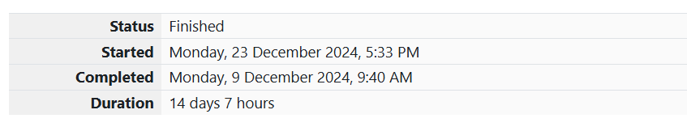
1. Problem Statement:
Given a sorted array AAA of integers and a non-negative integer kkk, find if there exist two indices iii and jjj such that A[i]−A[j]=kA[i] - A[j] = kA[i]−A[j]=k, where i≠ji \neq ji=j.
Input Format:
- First line contains the number of test cases TTT.
- For each test case:
  - First line contains NNN, the number of elements in the array.
  - Second line contains NNN integers representing the array.
  - Third line contains the integer kkk.
Output Format:
Print 1 if such a pair exists, otherwise print 0.
Sample Input:
Copy code
1
3
1 3 5
4
Sample Output:
Copy code
1

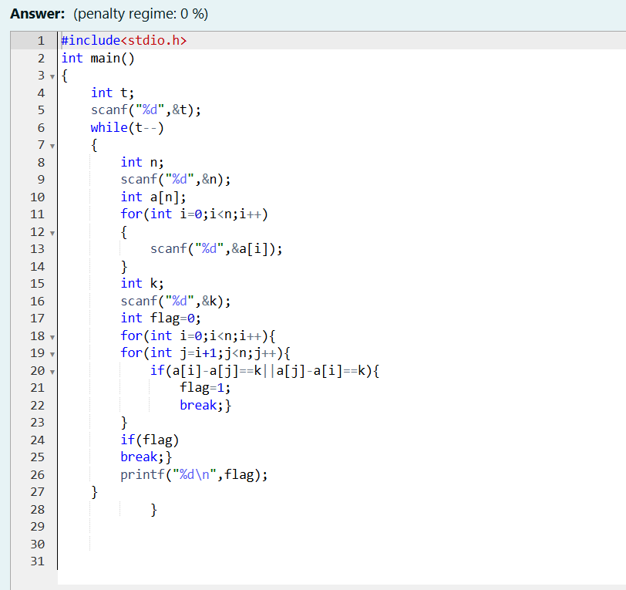
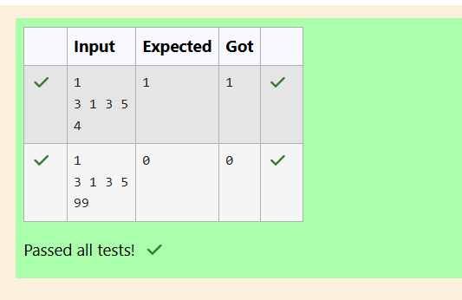
2. Problem Statement:
Sam loves chocolates and starts buying them on the 1st day of the year. Each day xxx (numbered from 1 to YYY), he follows these rules:
- On odd-numbered days, Sam buys xxx chocolates.
- On even-numbered days, Sam doesn’t buy any chocolates.
Input Format:
- The first line contains TTT, the number of test cases.
- Each of the following TTT lines contains an integer NNN — the number of days.
Output Format:
For each test case, print the total number of chocolates Sam has bought by day NNN.
Sample Input:
Copy code
3
1
2
3
Sample Output:
Copy code
1
1
4

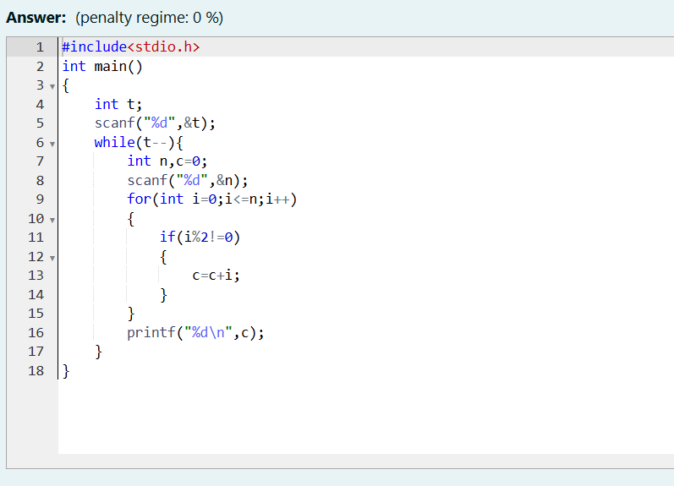
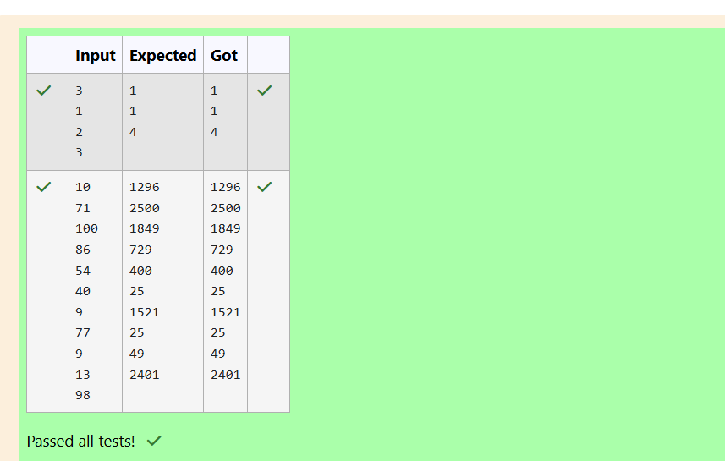
3. Problem Statement:
You are given the number of goals scored by two football teams in their respective matches. For each match of team B, find out how many matches of team A have scores less than or equal to the number of goals scored by team B in that match.
Input Format:
- An integer nnn, the number of matches played by team A.
- An array of nnn integers representing goals scored by team A.
- An integer mmm, the number of matches played by team B.
- An array of mmm integers representing goals scored by team B.
Output Format:
Print mmm integers where each integer represents the count of matches for team A.
Sample Input:
Copy code
4
1 4 2 4
2
3 5
Sample Output:
Copy code
2 4

